

TITLE

CASE STUDY

Submitted by
XXXXXXX (992200XXXX)

In partial fulfillment for the award of the degree of

BACHELOR OF TECHNOLOGY
in

INFORMATION TECHNOLOGY
Of



KALASALINGAM ACADEMY OF RESEARCH AND EDUCATION
(Deemed to be University)
Anand Nagar, Krishnankoil – 626 126
Academic Year 2025-26



School of Computing DEPARTMENT OF INFORMATION TECHNOLOGY

BONAFIDE CERTIFICATE

This is to certify that the case study titled “[TITLE OF THE CASE STUDY]” has been successfully completed by [STUDENT NAME] (Reg. No: 992200XXXX) in partial fulfillment of the requirements for the course “213INT2302 – Principles of Compiler Design” under my guidance during the academic year 2025-2026 (Even Semester).

Dr. S. Hemaswathi Associate Professor
Department of IT Kalasalingam Academy of Research and Education
Dr. N. C. Brintha
Associate Professor & HOD
Department of IT Kalasalingam Academy of Research and Education

Krishnankoil-626126. Krishnankoil-626126.

Abstract
Write a short summary of the case study in 5–6 lines explaining the following points:

  - What the case study is about
  - What compiler concept is used
  - What problem is solved
  - What solution is proposed

TABLE OFCONTENT

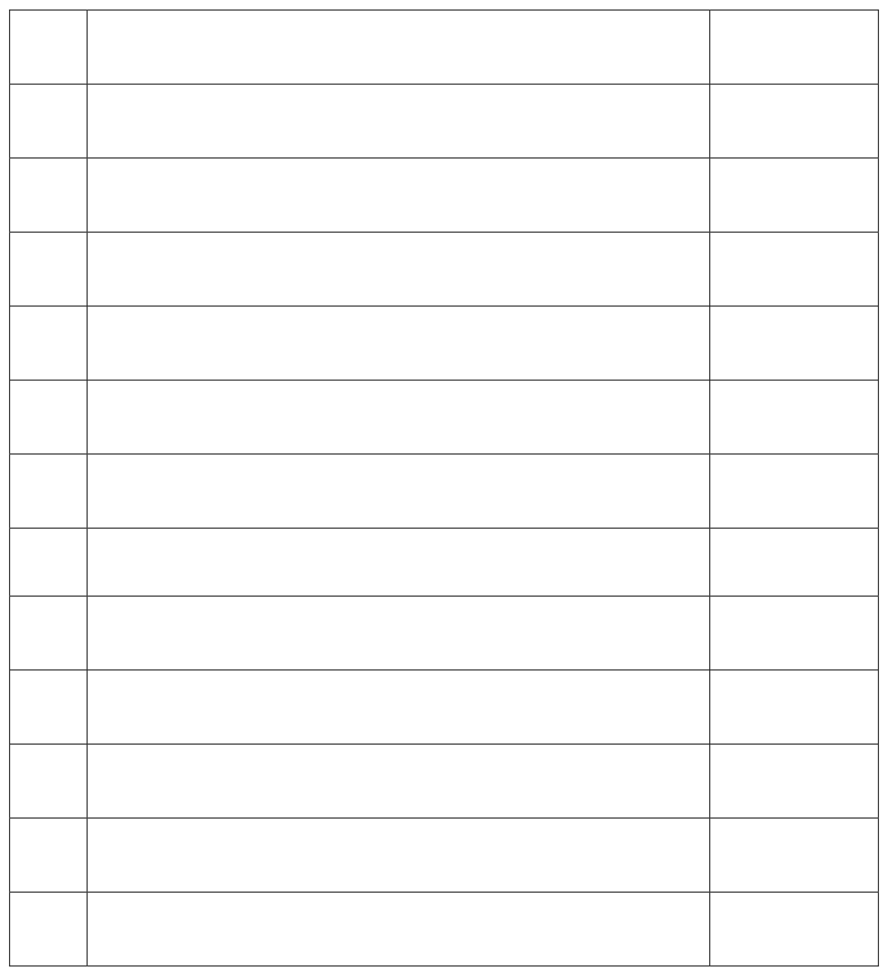
S. No Title Page No

- Introduction

- Problem Statement

- Objectives

- Methodology

- System Architecture

- Implementation

- Analysis and Discussion

- Applications

- Limitations

- Future Work

- Conclusion

- References

Introduction
Explain the background of the topic. Include:

  - What is the concept
  - Why it is important in compiler design
  - Where it is used in real compilers

Problem Statement
Clearly explain the problem addressed in this case study.

Example: Design a lexical analyzer capable of recognizing tokens such as identifiers, keywords, operators, and constants in a simplified programming language.

Objectives
Write 3–5 objectives for this case study.

Example Objectives:

  - To understand lexical analysis in compiler design
  - To implement token recognition techniques
  - To analyze compiler front-end functionality

Your Objectives:
  - [Objective 1]
  - [Objective 2]
  - [Objective 3]
  - [Objective 4]
  - [Objective 5]

Methodology / Approach
Explain how the problem is solved. Include any of the following as applicable:

  - Algorithm
  - Flowchart
  - Steps involved
  - Parsing technique
  - Code generation method

Example Structure:
- Step 1 – Input source program
- Step 2 – Token identification
- Step 3 – Syntax validation
- Step 4 – Intermediate representation

System Architecture / Diagram
Draw or insert one relevant diagram such as:

  - Compiler phase diagram
  - Parser tree
  - Control flow graph
  - Code generation model

(Hand drawn or software diagram is acceptable)

Implementation / Example
Provide an example program or input related to the case study.

Example Input Program:
int a = 10 + 20;

Then show the following based on your case study:
- Tokens generated
- Parse tree
- Intermediate code
- Machine code (if applicable)

Analysis and Discussion
Explain the following in approximately one page:

  - What results were obtained
  - How the compiler technique improved performance
  - Advantages of the approach

Applications
Explain real-world applications of the compiler concept used in this case study.

  - Programming language compilers
  - Code optimization
  - Embedded systems
  - Software development tools

Limitations
Mention any limitations of the approach used in this case study.

  - Limited grammar support
  - Works only for simple expressions
  - Does not handle complex control structures

Future Work
Summarize the findings of the case study in 5–6 lines.

Conclusion

- References
Include 2–3 references. Use proper citation format.

- Alfred V. Aho, Monica S. Lam, Ravi Sethi, Jeffrey D. Ullman — Compilers: Principles, Techniques and Tools (2nd Edition), Pearson, 2006.
- Allen I. Holub — Compiler Design in C, Prentice Hall, 1990.
- [Add research paper or online resource reference here]


Submission Requirements
Minimum Pages Must Include Font
Font Size
Line Spacing

20 – 25 pages
Diagram, Example, Explanation Times New Roman
12 pt
1.5

